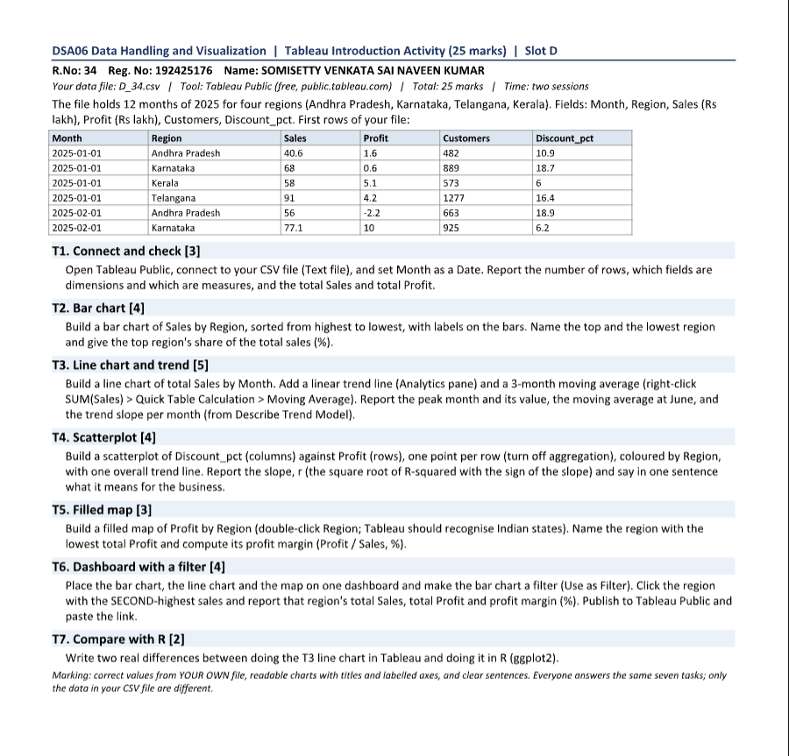

T1. Connect and check [3]
I connected to D_34.csv as a Text file and changed Month from text to Date. The file has 48 rows (4 regions × 12 months), with no missing values.
Dimensions: Month (Date) and Region (text). Measures: Sales, Profit, Customers and Discount_pct (all numeric).
Totals: total Sales = 3,801.4 lakh and total Profit = 290.7 lakh, an overall profit margin of 7.65%.

T2. Bar chart [4]
Region was placed on Columns and SUM(Sales) on Rows, sorted from highest to lowest, with Show Mark Labels switched on.
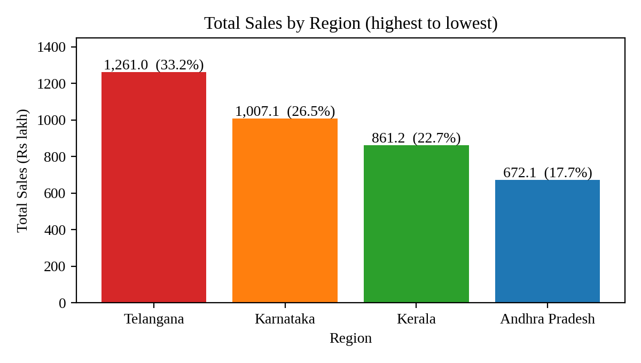
Figure 1. Total Sales by Region, sorted from highest to lowest.
Top region: Telangana, 1,261.0 lakh, which is 33.2% of total sales (1,261.0 / 3,801.4). Lowest region: Andhra Pradesh, 672.1 lakh (17.7%). Telangana sells about 1.9 times as much as Andhra Pradesh.

T3. Line chart and trend [5]
Month (continuous, month level) was placed on Columns and SUM(Sales) on Rows. A linear trend line was added from the Analytics pane, and a 3-month moving average was added with Quick Table Calculation > Moving Average on SUM(Sales) (the default window is the two previous months plus the current month).
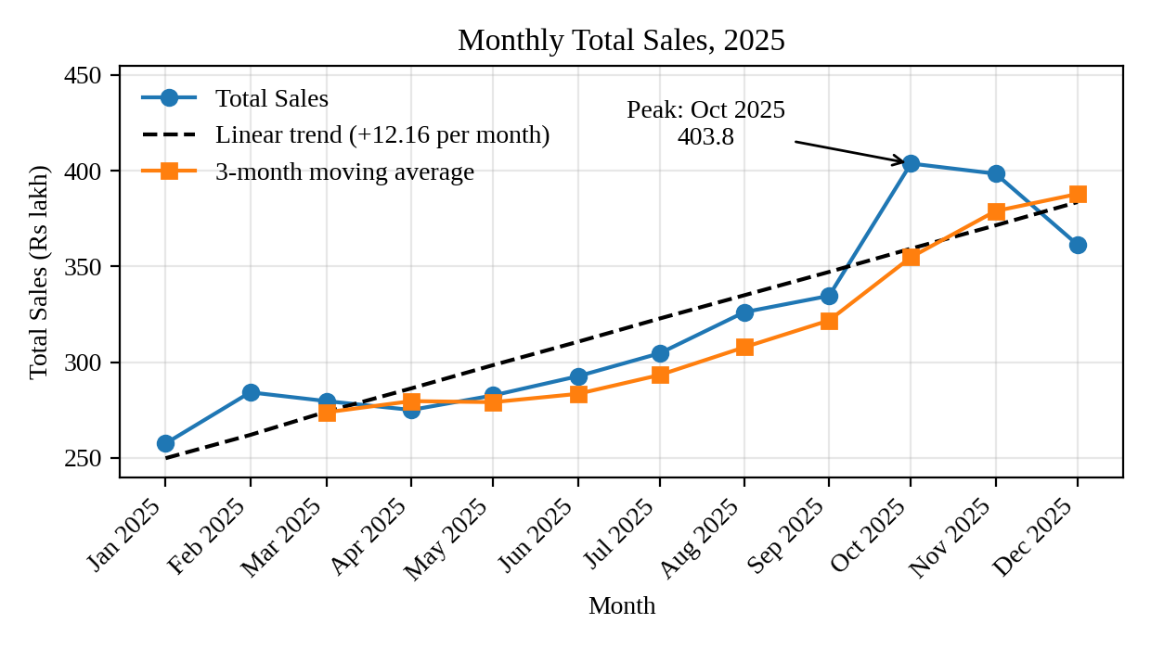
Figure 2. Monthly total Sales with linear trend and 3-month moving average.
Peak month: October 2025, with total sales of 403.8 lakh. Moving average at June: 283.5 lakh (the average of April 275.1, May 282.7 and June 292.7). Trend slope: +12.16 lakh per month (R² = 0.81, p < 0.001). Sales rose steadily from 257.6 lakh in January to a peak in October, then fell back to 361.4 lakh in December, while the trend line still points upward.

T4. Scatterplot [4]
Discount_pct was placed on Columns and Profit on Rows, Analysis > Aggregate Measures was switched off so that each of the 48 rows is one point, Region was put on Colour, and one overall trend line was added (Trend Lines > Show Trend Lines, with Show Trend Lines for Colour Segments switched off).
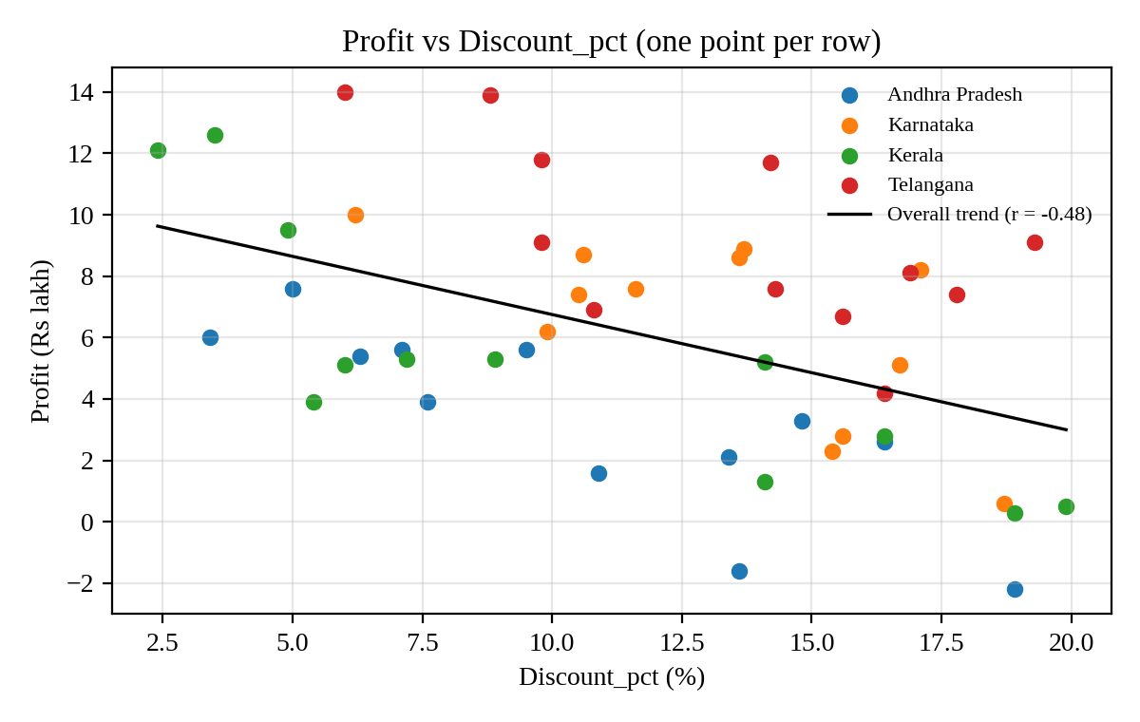
Figure 3. Profit against Discount_pct, coloured by Region, with one overall trend line.
Slope: -0.379 lakh of profit per extra percentage point of discount. r = -0.478, from R² = 0.228 (p < 0.001), taking the negative root because the slope is negative (r = -√0.228). The relationship is moderate and negative; inside each region it is even stronger (r between -0.66 and -0.84).
Meaning for the business: deeper discounts go with lower profit, about 3.8 lakh less profit per region-month for every 10 points of extra discount, so discounts should be capped unless they bring in enough extra sales.

T5. Filled map [3]
Region was double-clicked so that Tableau created a Latitude and Longitude and recognised the Indian states; Profit was put on Colour as a filled map.
[Paste here the Tableau filled map screenshot]
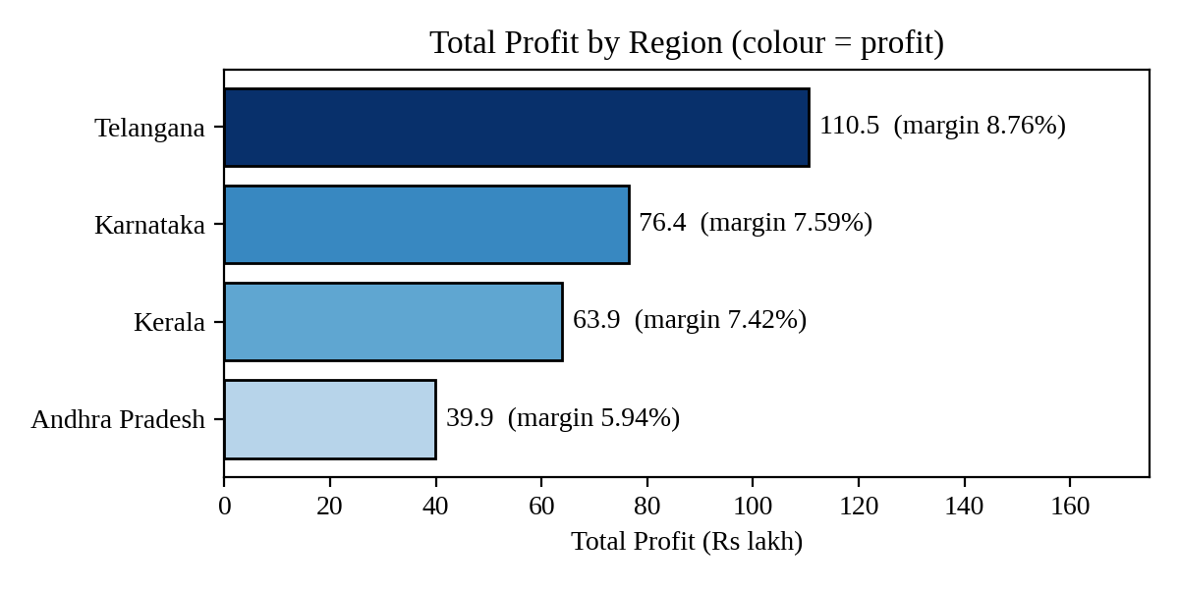
Figure 4. Total Profit by Region, shaded by profit as in the filled map.
Lowest total profit: Andhra Pradesh, 39.9 lakh. Its profit margin is 39.9 / 672.1 = 5.94%, which is also the lowest margin of the four regions (Kerala 7.42%, Karnataka 7.59%, Telangana 8.76%).

T6. Dashboard with a filter [4]
The bar chart, the line chart and the map were placed on one dashboard, and the bar chart was made a filter with the Use as Filter button. Clicking a region in the bar chart then updates the line chart and the map.
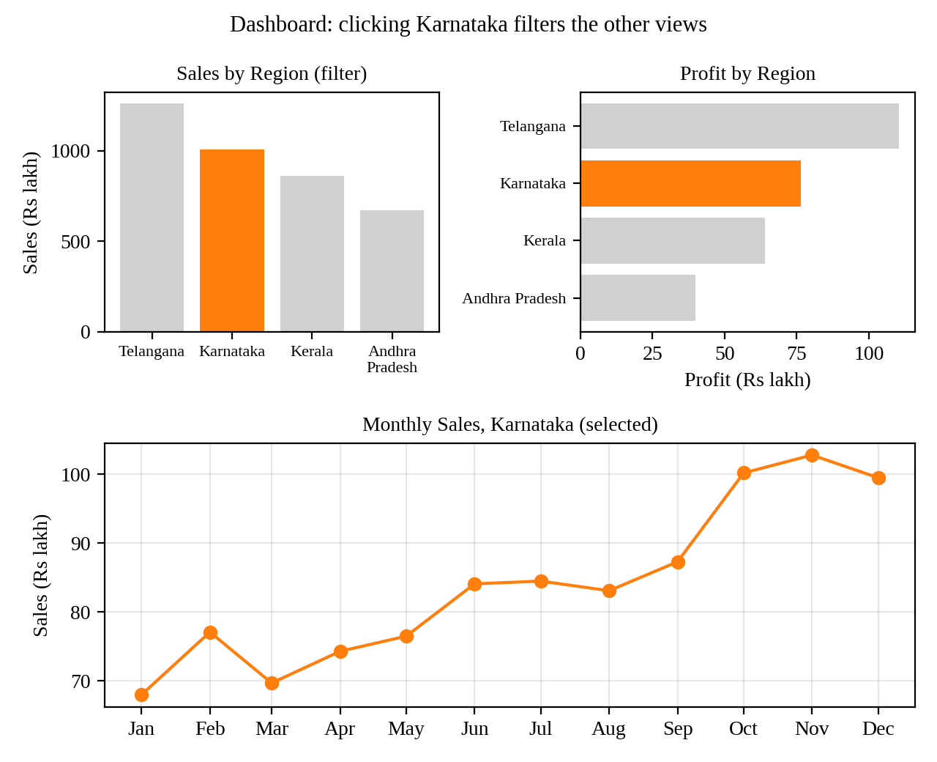
Figure 5. Dashboard layout with Karnataka selected in the bar chart.
Second-highest sales region: Karnataka. Total Sales = 1,007.1 lakh, total Profit = 76.4 lakh, profit margin = 76.4 / 1,007.1 = 7.59%.
Tableau Public link: [paste your published dashboard link here]

T7. Compare with R [2]
1. How the chart is built. In Tableau the line chart, the trend line and the moving average are made by dragging fields and using the Analytics pane and Quick Table Calculations, and Tableau reads the Month field as a date automatically. In ggplot2 everything is written as code: the date must be converted with as.Date(), the trend is a geom_smooth(method = "lm") layer, and the moving average has to be calculated separately (for example with zoo::rollmean) and added as another geom_line layer.
2. Repeatability and interactivity. A ggplot2 script can be re-run on a new file and gives exactly the same chart, and it can be saved and version-controlled, while the clicks in Tableau are not recorded as steps. On the other hand, Tableau charts are interactive straight away (hover tooltips, filters and dashboard actions), whereas a ggplot2 chart is static unless extra packages such as plotly or shiny are added.
ggplot(m, aes(Month, Sales)) + geom_line() + geom_smooth(method = "lm", se = FALSE)

